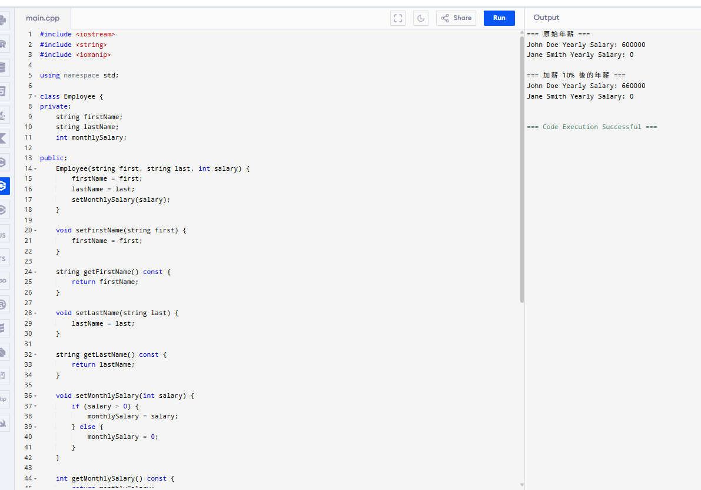

#include <iostream>
#include <string>
#include <iomanip>

using namespace std;

class Employee {
private:
string firstName;
string lastName;
int monthlySalary;

public:
Employee(string first, string last, int salary) {
firstName = first;
lastName = last;
setMonthlySalary(salary);
}

void setFirstName(string first) {
firstName = first;
}

string getFirstName() const {
return firstName;
}

void setLastName(string last) {
lastName = last;
}

string getLastName() const {
return lastName;
}

void setMonthlySalary(int salary) {
if (salary > 0) {
monthlySalary = salary;
} else {
monthlySalary = 0;
}
}

int getMonthlySalary() const {
return monthlySalary;
}
};

int main() {
Employee employee1("John", "Doe", 50000);
Employee employee2("Jane", "Smith", -10000);

cout << fixed << setprecision(2);

cout << "=== 原始年薪 ===" << endl;
cout << employee1.getFirstName() << " " << employee1.getLastName() << " Yearly Salary: " << employee1.getMonthlySalary() * 12 << endl;
cout << employee2.getFirstName() << " " << employee2.getLastName() << " Yearly Salary: " << employee2.getMonthlySalary() * 12 << endl;

int raise1 = employee1.getMonthlySalary() * 1.10;
employee1.setMonthlySalary(raise1);

int raise2 = employee2.getMonthlySalary() * 1.10;
employee2.setMonthlySalary(raise2);

cout << "\n=== 加薪 10% 後的年薪 ===" << endl;
cout << employee1.getFirstName() << " " << employee1.getLastName() << " Yearly Salary: " << employee1.getMonthlySalary() * 12 << endl;
cout << employee2.getFirstName() << " " << employee2.getLastName() << " Yearly Salary: " << employee2.getMonthlySalary() * 12 << endl;

return 0;
}

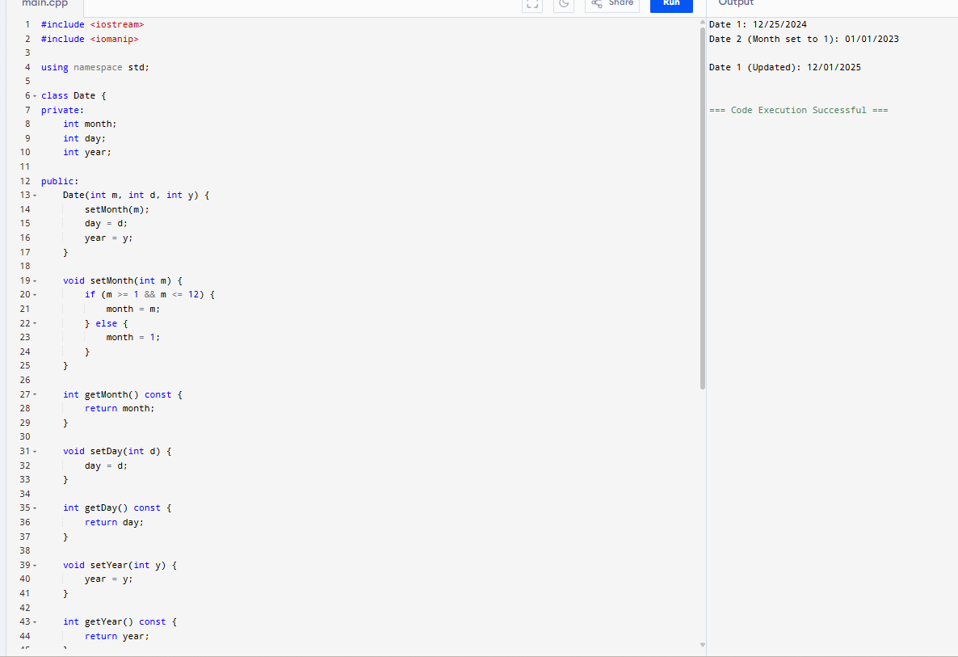

#include <iostream>
#include <iomanip>

using namespace std;

class Date {
private:
int month;
int day;
int year;

public:
Date(int m, int d, int y) {
setMonth(m);
day = d;
year = y;
}

void setMonth(int m) {
if (m >= 1 && m <= 12) {
month = m;
} else {
month = 1;
}
}

int getMonth() const {
return month;
}

void setDay(int d) {
day = d;
}

int getDay() const {
return day;
}

void setYear(int y) {
year = y;
}

int getYear() const {
return year;
}

void displayDate() const {
cout << setfill('0')
<< setw(2) << month << "/"
<< setw(2) << day << "/"
<< setw(4) << year;
}
};

int main() {
Date date1(12, 25, 2024);
Date date2(15, 1, 2023);

cout << "Date 1: ";
date1.displayDate();
cout << endl;

cout << "Date 2 (Month set to 1): ";
date2.displayDate();
cout << endl;

date1.setDay(1);
date1.setYear(2025);

cout << "\nDate 1 (Updated): ";
date1.displayDate();
cout << endl;

return 0;
}

